OFFICIAL COORDINATION REQUEST
FOR NON-ROUTINE OPERATIONS AND MAINTENANCE

COORDINATION TITLE- 15TDA13 railroad rail removal
COORDINATION DATE- Oct 29, 2015
PROJECT- The Dalles Dam
RESPONSE DATE- Nov 12, 2015

Description of the problem -

Type of outage required This is a follow-up from a previously coordinated MOC for rail removal. Derelict railroad rail removal will occur on the Intake and Tailrace Powerhouse decks. The area within 100’ of the East Fishway exit (intake deck) needs to occur between July and September. October and November will conflict with the AWS emergency backup construction.

Impact on facility operation – No operational changes are expected. Work within 100’ of the East Fishway exit and 50’ of other areas of the fishways during fish passage season. The work will involve some power equipment i.e. jackhammer.

Dates of impacts/repairs – First 2 weeks of August 2016. Annual grating inspections via ROV are normally scheduled during this time period due to the low point in fish passage between summer and fall runs.

Length of time for repairs – Two weeks

Expected impacts on fish passage –
Upstream migrants. Impact from vibration is unknown. Chinook and Steelhead are species of concern.
Ten year averages from DART:
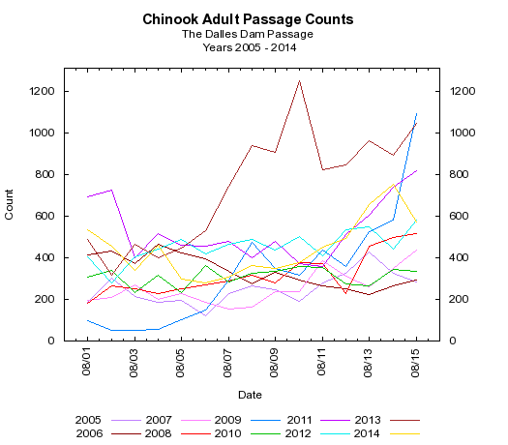
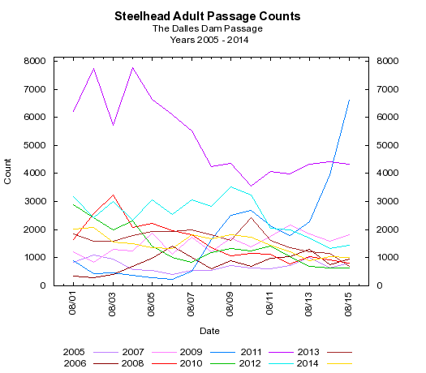

Downstream migrants. No expected juvenile passage near this area.

Lamprey – Impact from vibration is unknown.
Ten year average from DART:
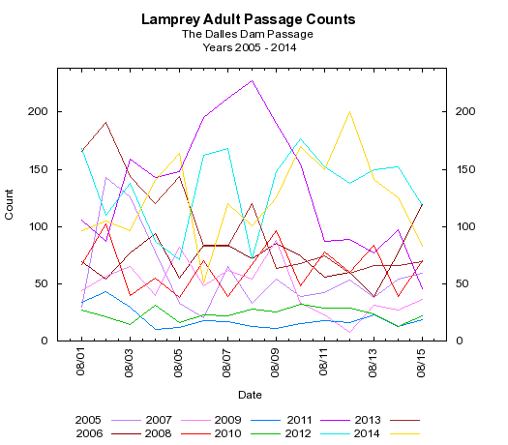

Bull Trout – impacts to Bull Trout are expected to be similar to other upstream migrating salmonids. Very few Bull Trout have been counted at TDA in the last 10 years. “WDFW and COE provided a list of anecdotal sightings/captures of bull trout in the mainstem Columbia River. From 2000 through 2012 there were eleven bull trout reported. Three were downstream of Bonneville Dam, with two at the mouth of Hamilton Creek (CRM 143) and one in 2005 at the Bonneville Dam Smolt Monitoring Facility (CRM 144). Upstream of the dam, one bull trout was found at Cascade Locks (CRM 149), two at Drano Lake (CRM 162), two at the mouth of the Klickatat River (CRM 180.5), one in 2002 at the John Day Dam Smolt Monitoring Facility (CRM 215), and one sighting at Dog Creek Falls by a reputable WDFW creel sampler who observed 18-24” cuts or dollies working old redds below the splash pool over the course of two weeks. “

Comments from agencies

Final results –

Please email or call with questions or concerns. Thank you,
Bob Cordie
TDA Project Fisheries
541-506-7800

Karrie Gibbons
NWP Operations Division Fishery Section
Columbia River Coordination Biologist
Karrie.m.gibbons@usace.army.mil

